Jahleel jean-jacques

ET501 J1 - Lab 1 Word Document

Jahleel Jean-Jacques

**Jahleel Jean-Jacques**

*Jahleel Jean-Jacques*

Jahleel Jean-Jacques

Jahleel Jean-Jacques

**THE JAZZICIANS**

***Present The***

**4th Annual Festival of *Jazz*.**

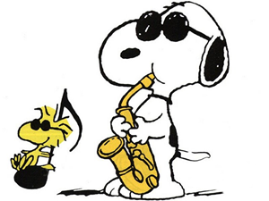

Ø Join us for a fun-filled day of entertainment for the whole family.

Ø The fun starts at 10:00 a.m. and ends at 11:00 p.m. on **Saturday, October 14, 2012**, at Riverfront Park.

Ø Festival attractions include games, rides, food, crafts, and live music from the talented artists of The Brass Beat, Dave and the Hornets, and The Nance Lance Band.

Hope to see you there!

**SAILING CLUB**

**Monthly Meeting**



**Plan to attend the meeting of the Sailing Club on May 1, 2012, in the auditorium of Queensborough Community College.**

**Ranger Robin Hood will lecture on:**

§ **Harbor Patrol rules and regulations**

§ **Basic sailing techniques**

**Please Call Little John, (718) 631-6207, to make your reservation.**

**Reservations Required**

**See You There!**

**Nuts for Sale**



**§ Hot, Juicy, and savory sweat flavored, salty, nut butter, and white nut spread among our many flavours.**

**§ Come on down to the Nut Shack where all your nut needs are meet.**

**§ Located in Nut Valley (718) Dee Nutz**

